**MKTG 1205 Week 9**

Activity 1: Sales Promotion

**Task:**

Propose supermarket/ shopping mall sales promotion tools to help the seller/ product in both **short-term sales** and **long-term brand preference** with its target segments. What benefit will you give to your customers to secure positive outcomes.

**Product Information:**

|  |  |  |  |  |
| --- | --- | --- | --- | --- |
| **Enchanteur Paris Eau De toilette Mon Amie 50ml**  120,000₫ | **Enchanteur Paris Mon amie Light & Fresh parfum Lotion 100ml**  50,000₫ | **Enchanteur Paris Hand & Body Lotion Light & Fresh 300ml**  75,000₫ | **Enchanteur Paris roll-on Deodorant Mon amie 50ml**  47,000₫ | **Enchanteur Paris deodorant Body Mist Mon amie 100ml**  51,050₫ |

**ENCHANTEUR** is a range of quality and timeless French inspired fine fragrances and fragrance infused body care products to spark moments of romance at every stage in woman’s wondrous journey of love.

**ENCHANTEUR Paris** is a collection of attractive French-inspired floral fruity fragrances for the joyful and elegant young woman. Life is filled with romance, excitement and friendship. There is always a perfect scent for that perfect moment. The range offers youthful and fun scents, making you the centre of attraction. “ENCHANTEUR Paris, *Made to Captivate*.”

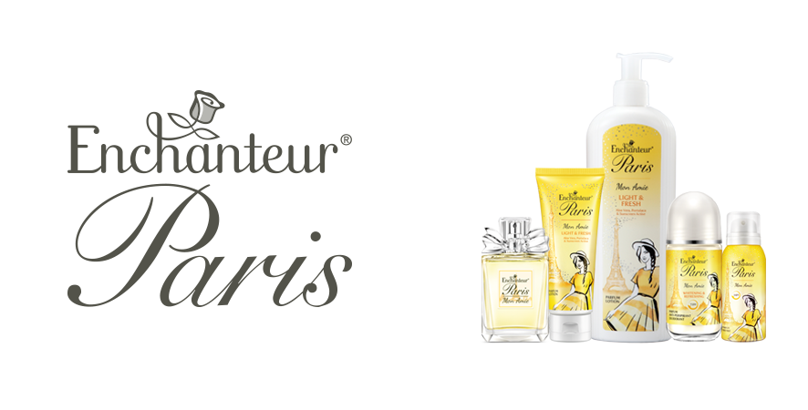

­­

|  |  |  |  |  |  |  |
| --- | --- | --- | --- | --- | --- | --- |
| **Segment** | **Profile** | **Needs** | **Market Share**  **%** | **Type Sales Promotion** | **Period of Promotion** | **Price/ Value Benefit to Customer** |
| We are family | Families with young children. Head of the family is 30 years up, low to middle spending, educated and is working rank and file or middle management job. | Physiological and safety needs. |  |  |  |  |
| Just the two of us | Married or co-habiting adults aged 24 years up, middle to high spending, educated, first time job holders or start-up entrepreneurs. | Love/belonging and self-actualization needs. |  |  |  |  |
| Crazy Cat Lady | Senior citizens, retired, living with family or by themselves with pets, low to middle spending, dependent on family’s/ government pension. | Physiological, safety and love/belonging needs. |  |  |  |  |
| #yolo | Young Adults, studying, living with parents or with guardians (not originally from Saigon), middle to low spending, may have a part-time job to supplement family support. | Esteem and self-actualization needs. | ­ |  |  |  |